**Rheology comparison through the statistical analysis of TITAN2D dynamics**

**Parameters ranges –** all uniformly sampled in linear scale, 256 samples

**Inclined plane experiment**  
VOLUME – [0.79, 1.21] x 10-3 m3

MC   
\phibed - [15’, 37’] *[tan(\phibed)=(0.27, 0.75), consistent with \mu of VS]*  
\phiint - [35’, 45’]  
  
VS  
\mu – [0.20, 0.80]  
\xi – [50, 5000]

PF  
\phi1 – [30’, 38’]  
\phi2 – [39’, 45’]  
\beta – [0.10, 0.85]  
L – [0.1, 10]

FIGURE 1 – Forces in X direction  
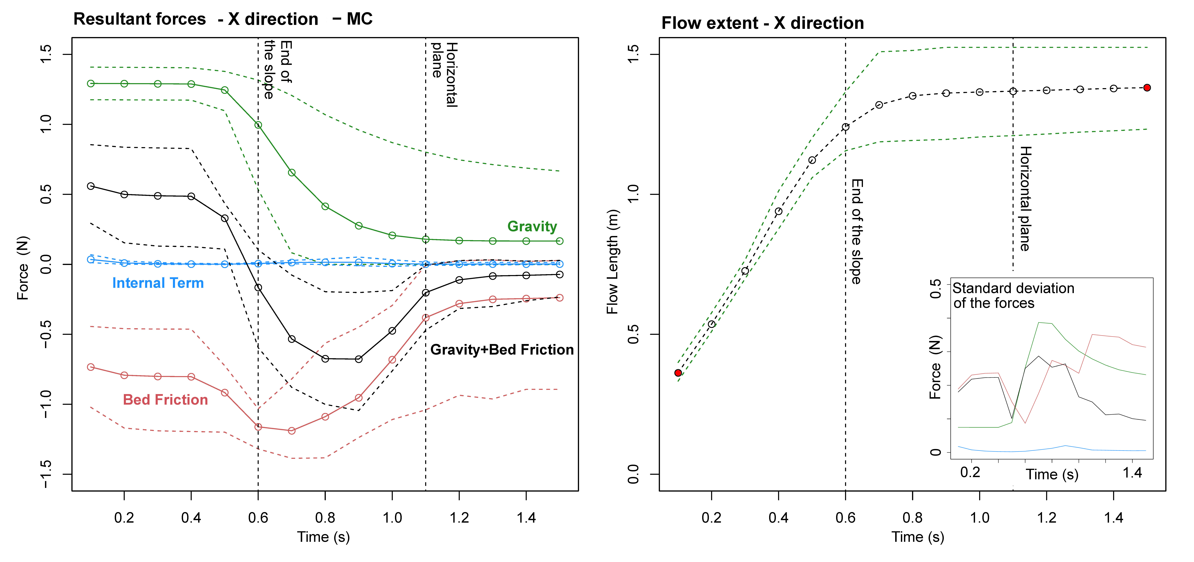  
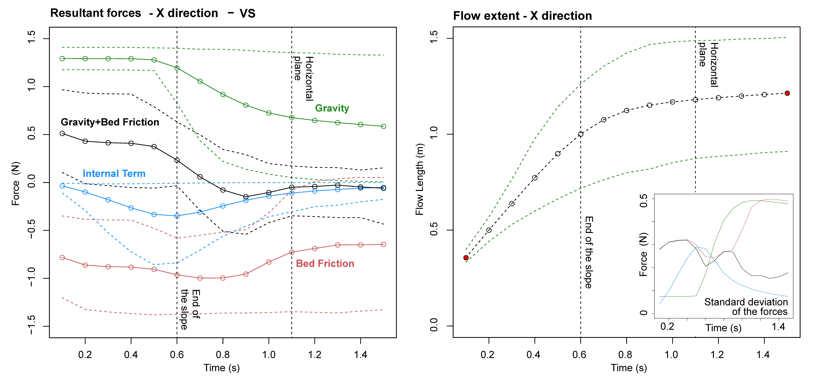  
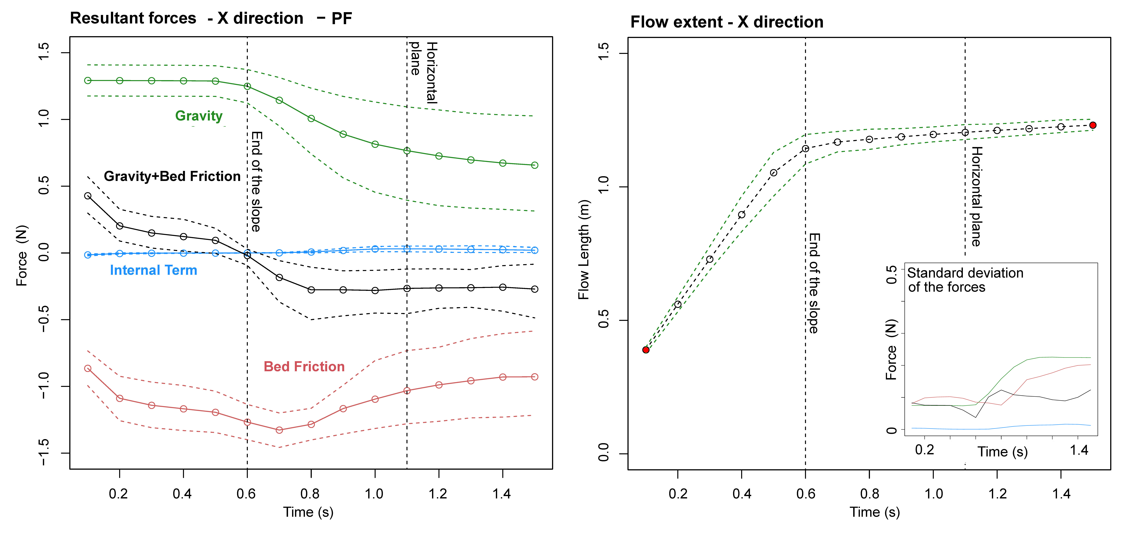

FIGURE 2 – Forces in Y direction  
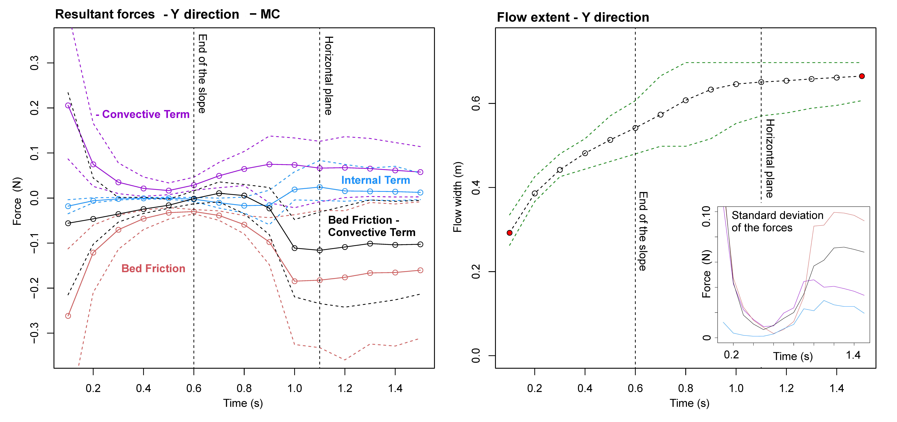  
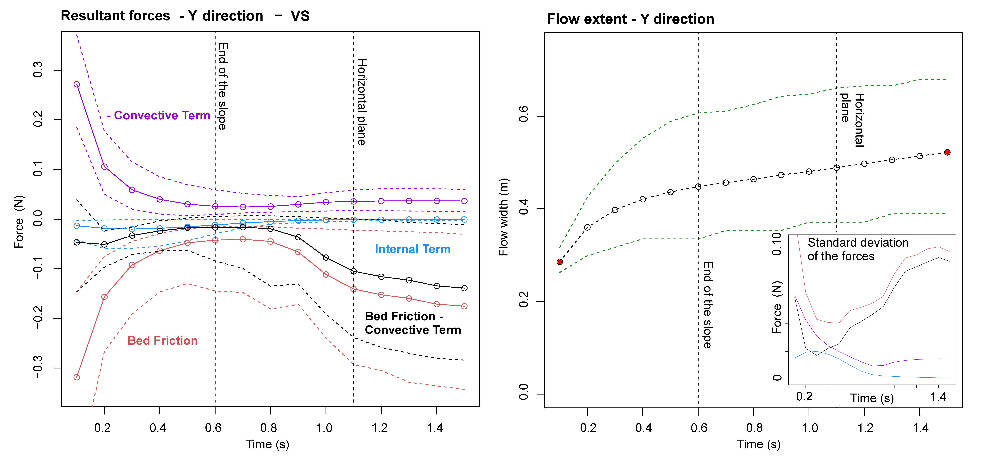  
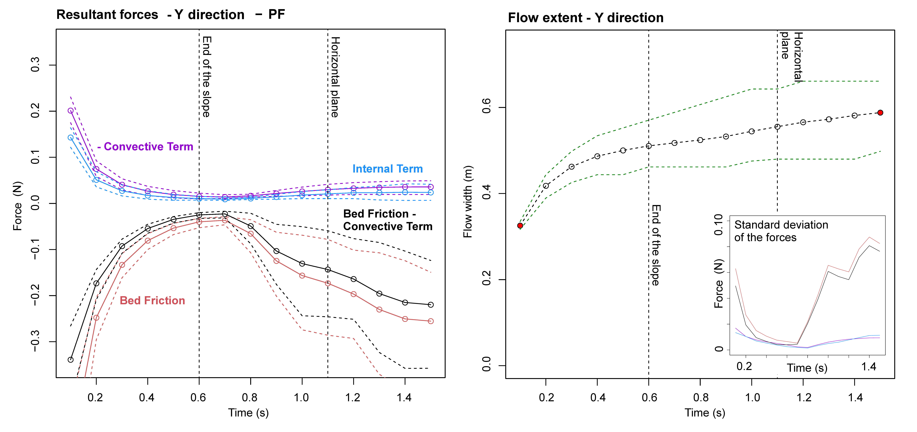 FIGURE 3 – Powers  
